WALMART WEEKLY SALES FORECATING
USING EXCLUSIVE DATA SCIENCE METHODS
Submitter by
AAKASH S
EA243121010306

Under the Guidance of
Dr.M.Muthuselvam
(Assistant Professor, Directorate of Online Education)
in partial fulfillment for the award of the degree of

BACHELOR OF COMPUTER APPLICATIONS



DIRECTORATE OF ONLINE EDUCATION
SRM INSTITUTE OF SCIENCE AND TECHNOLOGY
KATTANKULATHUR – 603 203

NOV 2025

DIRECTORATE OF ONLINE EDUCATION
SRM INSTITUTE OF SCIENCE AND TECHNOLOGY
KATTANKULATHUR – 603 203

BONAFIDE CERTIFICATE

This Project Work Report title “Walmart Weekly Sales Forecasting” of “AAKASH S [EA243121010306]”, who carried out the Project Work under my supervision along with the company mentor. Certified further, that to the best of my knowledge the work reported herein does not form any other internship report or dissertation based on which a degree or award was conferred on an earlier occasion on this or any other candidate.

PROJECT OFFER LETTER



ACKNOWLEDGEMENTS

We express our humble gratitude to Dr C. Muthamizhchelvan, Vice Chancellor, SRM Institute of Science and Technology, for the facilities extended for the project work and his continued support. We extend our sincere thanks to Director DOE, SRM Institute of Science and Technology, Prof. Dr Manoranjan Pon Ram, for his invaluable support. SRM Institute of Science and Technology, for her support throughout the project work. We want to convey our thanks to Programme Coordinator Dr. M.Muthuselvam, Directorate of online Education, SRM Institute of Science and Technology, for their inputs during the project reviews and support. Our inexpressible respect and thanks to my guide, Dr M.MuthuSelvam., Assistant Professor & Programme Coordinator Directorate of online Education,, SRM Institute of Science and Technology, for providing me with an opportunity to pursue my project under her mentorship. She provided me with the freedom and support to explore the research topics of my interest. Her passion for solving problems and making a difference in the world has always been inspiring. We sincerely thank the Directorate of online Education, staff and students, SRM Institute of Science and Technology, for their help during our project. Finally, we would like to thank parents, family members, and friends for their unconditional love, constant support, and encouragement.

AAKASH S

TABLE OF CONTENTS

CHAPTER NO. TITLE PAGE NO.
- Abstract
- Classification of Machine Learning………………………………………7
- Problem Description………………………………………………………9
- System Requirements……………………………………………………..10
- Tools & Technology………………………………………………………11
- System Design……………………………………….,,…………………..16
- Implementation……………………………………………………………18
- Coding……………………………………………………………………..22
- Testing…………………………………………………………………….27
- Conclusion………………………………………………………………...33
- Reference………………………………………………………………….34

- ABSTRACT

This project describes the creation of a solid machine learning pipeline to forecast weekly sales at Walmart stores and offer insights into key factors affecting demand. Using a historical dataset that includes sales figures, holidays flags, and economic factors like CPI, unemployment, and fuel price, the solution applied effective techniques to tackle the complexity and seasonality of retail sales data.
The main approach included thorough data preprocessing, detailed feature engineering, and the use of an XGBoost Regressor model. The trained model showed strong predictive performance, highlighted by a high R2 score and low Mean Absolute Error and Root Mean Squared Error on the time-split test set.
Walmart operates a Huge No of stores across different regions in the U.S., and weekly sales fluctuate due to holidays, promotions, seasonality, and economic conditions. The goal of this project is to forecast future weekly sales for each store to help Walmart optimize inventory, staffing, and marketing strategies. Helps allocate workers efficiently during high or low sales weeks. Improves revenue prediction and budgeting accuracy.

- Introduction

2.1 Project Background and Context
In the competitive and low-margin retail sector, predicting future demand is crucial for making a profit and running operations smoothly. For a large company like Walmart, which has huge number of stores and manages extensive inventory and complex supply chains, misjudging weekly demand can result in significant financial losses. This can happen through lost sales from understocking or increased costs from overstocking.
This project intends to address these challenges by creating a weekly sales forecasting model. It makes use of a rich dataset that captures the complex dynamics of retail. This data combines weekly sales figures with different influencing factors like holiday flags, store attributes, and outside economic indicators such as the Consumer Price Index (CPI), unemployment rate, and fuel price. This broad view allows us to build a predictive model that goes beyond simple linear trend analysis.
2.2 Problem Statement
The main goal is to predict Weekly_Sales for each store as accurately as possible while clearly explaining the reasons behind these predictions. The current data-driven approach must shift from descriptive analytics, which explains what happened, to predictive and prescriptive analytics, which forecasts what will happen and why. The solution needs to manage the complex relationships and high volatility present in retail sales data, particularly during busy seasons and promotions.
2.3 Project Objectives
This project has three main objectives: Develop a High-Accuracy Forecasting Model: Create a supervised machine learning model (XGBoost Regressor) that accurately predicts weekly sales for a set future period (30 weeks) using historical trends and external variables. This changes the model from a black box into a useful business tool. Create Actionable Deliverables: Produce a final output that business stakeholders and analysts can use immediately. This includes a clean CSV file that can be used to create a detailed Power BI dashboard, featuring both point forecasts and calculated prediction intervals.
2.4 Methodology
To achieve these objectives, the project followed a structured data science process:
Data Cleaning and Feature Engineering:
Addressed missing data and created highly predictive features, such as lagged sales variables and rolling averages, which are crucial for capturing time-series trends.
Model Training:
Trained and validated the XGBoost model using a strict time-based split to simulate real-world forecasting conditions.
Forecasting and Interval Creating:
Used the best-performing model to create a week sales forecast, including necessary prediction bounds to communicate uncertainty to the business.
Reporting and Visualization:
Documented feature importance and exported the final forecast dataset for easy integration into the business intelligence system.

- PROBLEM DESCRIPTION

4.1 Problem Statement
The core challenge is the lack of a highly accurate, automated system for weekly sales forecasting within a large-scale retail environment. Inability to accurately predict weekly sales fluctuations leads to significant revenue leakage through inefficient inventory management (lost sales from understocking or excess costs from overstocking) and suboptimal staffing decisions.
The problem is one of multivariate, non-linear time series prediction. We must accurately model the relationship between the target variable, Weekly Sales, and a rich set of explanatory features, including:
- Internal Controls: Store identifiers and sales history.
- External Factors: Fuel Price, Unemployment Rate, Consumer Price Index (CPI).
- Environmental Factors: Temperature and Holiday Flags.
The goal is to transition from descriptive analytics ("what happened") to predictive and prescriptive analytics ("what will happen and why").

- SOFERWARE REQUIREMENT ANALYSIS

4.1 Introduction
Software Requirement Analysis b is the process of understanding and documenting what is required to develop and implement the system successfully. It defines the functional and non-functional requirements of both the hardware and software components used in the project.
In this project, the goal is to build a Weekly Sales Forecasting System for Walmart using Python for analysis and forecasting, and Power BI for visualization and reporting.

4.2 Hardware Specification
To run the forecasting model and Power BI dashboards efficiently, the following hardware components we need:
- Processor: Intel Core i5 or higher
- RAM: Minimum 8 GB (16 GB recommended for faster processing)
- Storage: At least 500 GB HDD or 256 GB SSD
- Graphics: Basic integrated graphics (for visualization rendering)
- Display: 1366 × 768 resolution or higher
- Internet Connection: Required for Power BI updates and cloud sync
These specifications ensure smooth operation while performing data preprocessing, model training, and dashboard visualization.

4.3 Software Specification
The software requirements for this project include:
- Operating System: Windows 10 / 11 (or any OS compatible with Python & Power BI)
- Programming Language: Python 3.x
- Development Environment: Jupyter Notebook / Google Colab / VS Code

- TOOLS & TECHNOLOGY

5.1Introduction to Python

Python is a high-level, general-purpose programming language created by Guido van Rossum and released in 1991. It is one of the most popular languages in the world because of its simplicity, readability, and flexibility. Python allows developers to focus on solving problems rather than dealing with complex syntax. It is an interpreted language, meaning it executes code line by line, making it easier to test and debug. Python is also cross-platform, which means the same code can run on Windows, macOS, and Linux without any modification. Being open-source, it is freely available and supported by a large global community.

Applications of Python
Python is used in many fields, including:
- Data Science and Machine Learning – analyzing data, building predictive models.
- Web Development – creating websites using frameworks like Django and Flask.
- Automation – automating repetitive computer tasks.
- Artificial Intelligence and Deep Learning – using libraries such as TensorFlow and PyTorch.
- Visualization – creating charts and dashboards with Matplotlib, Seaborn, or Power BI integration.
Libraries Used in Python:
- pandas → For loading, cleaning, and managing the Walmart sales data.
- numpy → For performing numerical and mathematical operations.
- matplotlib.pyplot → For creating visualizations like line and trend plots.
- seaborn → For improving visualization aesthetics and statistical charts.
- xgboost → The main machine learning model used for weekly sales forecasting.
- train_test_split → To divide data into training and testing sets.
- mean_squared_error, r2_score, mean_absolute_error → For evaluating model performance.
- deque (from collections) → To efficiently handle lag features in time-series forecasting.
- tqdm → To show progress bars while forecasting all 45 stores

Role of Python in Walmart Weekly Sales Forecasting Project
In this project, Python plays a crucial role in handling data and building the forecasting model. It is used to import, clean, and preprocess Walmart’s historical sales data. Python libraries such as Pandas and NumPy are used for data manipulation, while Matplotlib and Seaborn help in exploring trends through visualizations. For forecasting, machine learning libraries like Scikit-learn, XGBoost,
5.2 Machine Learning
Supervised Learning:
Supervised learning is the machine learning task of learning a function that maps an input to an output based on example input-output pairs. The given data is labelled. Both classification and regression problems are supervised learning problems. Supervised learning, also known as supervised machine learning, is a subcategory of machine learning and artificial intelligence. It is defined by its use of labeled datasets to train algorithms that to classify data or predict outcomes accurately. As input data is fed into the model, it adjusts its weights until the model has been fitted appropriately, which occurs as part of the cross-validation process. Supervised learning helps organizations solve for a variety of real-world problems at scale, such as classifying spam in a separate folder from your inbox.
Unsupervised Learning:
Unsupervised learning is a type of machine learning algorithm used to draw inferences from datasets consisting of input data without labeled responses. In unsupervised learning algorithms, classification or categorization is not included in the observations. As a kind of learning, it resembles the methods humans use to figure out that certain objects or events are from the same class, such as by observing the degree of similarity between objects. Some recommendation systems that you find on the web in the form of marketing automation are based on this type of learning.
Semi-Supervised Machine Learn:
The students learn both from their teacher and by themselves in Semi-Supervised Machine Learning. And you can guess that from the name itself! This is a combination of Supervised and Unsupervised Machine Learning that uses a little amount of labeled data like Supervised Machine Learning and a larger amount of unlabeled data like Unsupervised Machine Learning to train the algorithms. First, the labeled data is used to partially train the Machine Learning Algorithm, and then this partially trained model is used to pseudo-label the rest of the unlabeled data. Finally, the Machine Learning Algorithm is fully trained using a combination of labeled and pseudo-labeled data
Role Of Machine Learning
In this project Machine Learning plays the major role for forecasting and training model. Here I used Supervised learning for training model named XGBoost (Extreme Gradient Boosting).

What is Gradient Boosting?
Gradient Boosting builds multiple weak learners (usually decision trees) sequentially.
Each new tree tries to correct the errors made by the previous trees.
- First model: Makes predictions (may be inaccurate)
- Next models: Learn from the errors (residuals)
- Final model: Combination of all trees → strong predictive model

Advantages
- Very high accuracy
- Works well with default parameters
- Handles missing values and irregular data
- Scales well to large datasets

Disadvantages
- Can be computationally heavy
- Hard to interpret compared to simple models

5.3 Power BI

Introduction
Power BI is a business analytics and data visualization tool developed by Microsoft. It helps users analyze data, create interactive dashboards, and generate real-time reports from various data sources such as Excel, SQL, or CSV files.
Power BI allows both technical and non-technical users to explore data visually and make better business decisions. It transforms raw data into meaningful insights through interactive charts, graphs, and KPIs (Key Performance Indicators).

Features of Power BI
Power BI offers several powerful features that make it a popular choice for data analysis and visualization:
- Data Connectivity: It can connect to multiple data sources like Excel, databases, web APIs, and cloud services.
- Interactive Dashboards: Users can interact with visuals, apply filters, and drill down into detailed insights.
- Data Modeling: Power BI allows combining, cleaning, and transforming data easily using Power Query.
- Real-Time Analytics: Dashboards can refresh automatically to show the most recent data.
- Integration: Works seamlessly with Microsoft products such as Excel, Azure, and Teams.
- AI Capabilities: Built-in AI visuals help detect patterns, trends, and anomalies automatically.

Role of Power BI in Walmart Weekly Sales Forecasting Project
In this Walmart project, Power BI plays a key role in visualizing and communicating insights from your forecasting model.
After Python generates the predicted weekly sales, the results are imported into Power BI for further analysis.
Using Power BI, we can:
- Display actual vs. predicted sales using line charts.
- Highlight trends and seasonal patterns visually.
- Build interactive dashboards that allow users to explore data by store, department, or time period.
- Present clear and professional reports for decision-making.
Thus, Power BI serves as the visualization and reporting layer of this project is used to convert machine learning results into easy-to-understand, interactive insights.

- SYSTEM DESIGN
6.1 High Level UML Diagram
Import Data Set
Train Model
Export

Analyst
Predict Sales

Visualize
6.2 Work Flow
Analysist

Visualization
Data Analyst

Adding Datasets
Model Training
Data Collecting
Fit Transform
Forecasting
Data Preprocessing

Add Plots
Feature Engineering
Testing
Publish
Exporting Dataset

6.3 E-R Diagram
Forecast Result
Store Records
Store

Store ID
Date
Weekly Sales
Data_Type
Week
Predicted sales

- Store: Contains store-level details.
- Sales_Record: Stores weekly sales and related attributes (temperature, fuel price, etc.).
- Forecast_Result: Holds the model’s predicted sales for future weeks
- Each store can have multiple sales records, and each sales record corresponds to a forecast.

- IMPLEMENTATION

7.1 Introduction
The implementation phase is where the actual development of the Walmart Weekly Sales Forecasting System takes place.
In this phase, the designed system is transformed into a working model using Python for data processing and forecasting and Power BI for visualization.
This stage involves coding, testing, and integrating all modules to generate accurate weekly sales forecasts for Walmart stores.

7.2 Steps in Implementation

Data Collection
- The dataset was obtained from the Walmart Weekly Sales dataset, which includes historical data for multiple stores and departments.
- Each record contains features such as:
  - Store number
  - Department number
  - Date
  - Weekly Sales
  - Temperature
  - Fuel Price
  - CPI (Consumer Price Index)
  - Unemployment rate
This data forms the base for training the forecasting model.

Data Preprocessing
Before applying machine learning models, data cleaning and feature engineering were performed.
Tasks included:
- Handling missing or null values
- Converting the Date column into a datetime format
- Sorting data by Store, Department, and Date
- Creating lag features and rolling averages to capture past trends
- Normalizing data for consistent model performance
This ensures data quality and prepares it for forecasting.

Exploratory Data Analysis (EDA)
- Visualized weekly sales trends over time
- Identified seasonal patterns such as holiday peaks (Christmas, Thanksgiving, etc.)
- Detected any outliers or anomalies using distribution and box plots
- Correlation analysis was done to understand how factors like CPI, temperature, and fuel price affect sales.
This step helps in understanding the business behavior behind the numbers.

Feature Engineering
To improve prediction accuracy, additional features were created such as:
- Lag features: previous week/month sales
- Rolling mean and standard deviation: to capture trends and seasonality
- Holiday flag: indicating special sales weeks
- Year, Month, Week number: for temporal analysis
These features help the model learn hidden patterns in sales data

Model Development
The forecasting model was developed using Python libraries like:
- Pandas and NumPy for data manipulation
- Matplotlib and Seaborn for visualization
- Scikit-learn for training machine learning models
Models tried:
- Linear Regression
- Random Forest Regressor
- XGBoost Regressor
After evaluation, the model with the highest accuracy and lowest error (RMSE, MAE) was selected for deployment.

Model Evaluation
The trained models were tested on unseen data.
Metrics used:
- Mean Absolute Error (MAE) – measures average prediction error
- Root Mean Square Error (RMSE) – measures overall deviation
- R² Score – measures how well the model explains the variance in sales
The final model achieved high accuracy and captured seasonal fluctuations effectively.
Forecast Generation
Using the trained model, future weekly sales were predicted for each store and department.
The forecasts were exported into a CSV file and later imported into Power BI for visualization.

Power BI Dashboard Implementation
Power BI was used to design an interactive dashboard that displays:
- Weekly sales trends
- Seasonal and yearly patterns
- Predicted vs. actual sales comparison
- Store-wise and department-wise performance
- Impact of CPI and Unemployment on sales
Charts used:
- Line chart (for trend visualization)
- Area chart (for seasonality)
- Bar chart (for store performance comparison)
- KPI cards (for key metrics)
This dashboard helps Walmart managers make data-driven business decisions.

- Coding
# Import libraries
import pandas as pd
import numpy as np
import matplotlib.pyplot as plt
import seaborn as sns
import xgboost as xgb
from sklearn.model_selection import train_test_split
from sklearn.metrics import mean_squared_error, r2_score, mean_absolute_error
from collections import deque
from tqdm import tqdm

#Data Loading
try:
df = pd.read_csv("/content/Walmart Actual DataSet.csv")
print("File loaded successfully")
except FileNotFoundError:
print("File not found. Please check the file path.")

df.head()
df.info()
df.info()
df.isnull().sum().sum()
df.describe()
df

#changing Data Type As date for Date col
df['Date'] = pd.to_datetime(df['Date'], format='%d-%m-%Y')
df = df.sort_values(by=['Store', 'Date']).reset_index(drop=True)

def create_features(df):
df['Year'] = df['Date'].dt.year
df['Month'] = df['Date'].dt.month
df['Week'] = df['Date'].dt.isocalendar().week.astype(int)
df['DayOfWeek'] = df['Date'].dt.dayofweek
df['Quarter'] = df['Date'].dt.quarter
df['DayOfYear'] = df['Date'].dt.dayofyear
df['Store'] = df['Store'].astype(int)
# Average sales per store
df['Store_Avg_Sales'] = df.groupby('Store')['Weekly_Sales'].transform('mean')

# Lagged features
for col in ['Temperature','Fuel_Price','CPI','Unemployment']:
df[f'{col}_Lag_1'] = df.groupby('Store')[col].shift(1)
# Holiday flags
df['Is_SuperBowl_Week'] = ((df['Date'].dt.month==2) & df['Date'].dt.day.between(5,15)).astype(int)
df['Is_LaborDay_Week'] = ((df['Date'].dt.month==9) & df['Date'].dt.day.between(5,15)).astype(int)
df['Is_Thanksgiving_Week'] = ((df['Date'].dt.month==11) & df['Date'].dt.day.between(20,30)).astype(int)
df['Is_Christmas_Period'] = ((df['Date'].dt.month==12) & df['Date'].dt.day.between(20,31)).astype(int)

# Weekly sales lags
lags = [1,2,4,8,12,52]
for lag in lags:
df[f'Weekly_Sales_Lag_{lag}'] = df.groupby('Store')['Weekly_Sales'].shift(lag)

# Rolling features
df['Rolling_Mean_4'] = df.groupby('Store')['Weekly_Sales'].transform(lambda x: x.shift(1).rolling(4).mean())
df['Rolling_Std_4'] = df.groupby('Store')['Weekly_Sales'].transform(lambda x: x.shift(1).rolling(4).std())

# Weight for holidays
df['Weight'] = np.where(df['Holiday_Flag']==1, 5, 1)

# Drop rows with critical missing features
df = df.dropna(subset=['Weekly_Sales_Lag_1','Rolling_Mean_4']).reset_index(drop=True)

return df

# Create features
df_model = create_features(df.copy())

# Encode categorical columns
cat_cols = ['Month','DayOfWeek','Quarter']
df_model_enc = pd.get_dummies(df_model, columns=cat_cols, drop_first=False)
# Define features from the encoded datafram
features = [col for col in df_model_enc.columns if col not in ['Date','Weekly_Sales','Weight']]
# train-test split
max_date = df_model_enc['Date'].max()
test_split_date = max_date - pd.Timedelta(weeks=30)
train_df = df_model_enc[df_model_enc['Date'] <= test_split_date]
test_df = df_model_enc[df_model_enc['Date'] > test_split_date]

X_train, y_train = train_df[features], train_df['Weekly_Sales']
X_test, y_test = test_df[features], test_df['Weekly_Sales']
w_train, w_test = train_df['Weight'].values, test_df['Weight'].values
print(f"Training samples: {len(X_train)}, Test samples: {len(X_test)}")

# Train XGBoost model with DMatrix
dtrain = xgb.DMatrix(X_train, label=y_train, weight=w_train)
dtest = xgb.DMatrix(X_test, label=y_test, weight=w_test)

params = {
'objective': 'reg:squarederror',
'learning_rate': 0.05,
'max_depth': 6,
'subsample': 0.8,
'colsample_bytree': 0.8,
'seed': 42
}

evals = [(dtrain, 'train'), (dtest, 'eval')]

xgb_model_booster = xgb.train(
params=params,
dtrain=dtrain,
num_boost_round=500,
evals=evals,
early_stopping_rounds=50,
verbose_eval=50
)

xgb_model = xgb.XGBRegressor(
objective='reg:squarederror',
learning_rate=0.05,
max_depth=6,
subsample=0.8,
colsample_bytree=0.8,
seed=42)
# Fit without early stopping first
xgb_model.fit(X_train, y_train, sample_weight=w_train, verbose=True)

y_pred = xgb_model.predict(X_test)

test_df['Predictions'] = y_pred
# Evaluation
mae = mean_absolute_error(y_test, y_pred)
rmse = np.sqrt(mean_squared_error(y_test, y_pred))
r2 = r2_score(y_test, y_pred)
wmae = np.sum(w_test * np.abs(y_test - y_pred)) / np.sum(w_test)

print(f"MAE: {mae:.2f}, RMSE: {rmse:.2f}, R2: {r2:.4f}, WMAE: {wmae:.2f}")

def recursive_forecast(store_df, model, features, horizon = 30):
store_df = store_df.sort_values('Date').reset_index(drop=True)

# Ensure all features exist
for feat in features:
if feat not in store_df.columns:
store_df[feat] = 0

lag_cols = [f'Weekly_Sales_Lag_{lag}' for lag in [1, 2, 4, 8, 12, 52]]
lag_dict = {col: deque(store_df[col].tail(int(col.split('_')[-1])),
maxlen=int(col.split('_')[-1])) for col in lag_cols}

last_row = store_df.iloc[-1].copy()
predictions = []

for _ in range(horizon):
# Update lag features
for col in lag_cols:
last_row[col] = lag_dict[col][-1] if len(lag_dict[col]) > 0 else 0

# Rolling mean
last_row['Rolling_Mean_4'] = (
np.mean(list(lag_dict['Weekly_Sales_Lag_4']))
if len(lag_dict['Weekly_Sales_Lag_4']) > 0 else 0
)
# Prepare input for model
X_input = pd.DataFrame([last_row[features].fillna(0).values], columns=features)
# Predict
y_pred = model.predict(xgb.DMatrix(X_input))[0]
predictions.append(y_pred)

# Update lag dict
for col in lag_cols:
lag_dict[col].append(y_pred)

# Advance date
last_row['Date'] += pd.Timedelta(weeks=1)
last_row['Week'] = (last_row['Week'] + 1) % 52
if last_row['Week'] == 0:
last_row['Year'] += 1

forecast_dates = pd.date_range(store_df['Date'].iloc[-1] + pd.Timedelta(weeks=1),
periods=horizon, freq='W')

return pd.DataFrame({
'store_id': store_df['Store'].iloc[-1],
'Date': forecast_dates,
'Weekly_Sales': predictions
})
forecast_list = []
print("\n-30week forecasts for all stores...\n")
for store_id in tqdm(df_model_enc['Store'].unique(), desc="Forecasting Stores"):
store_df = df_model_enc[df_model_enc['Store'] == store_id]
fc_df = recursive_forecast(store_df, xgb_model_booster, features, horizon=30)
forecast_list.append(fc_df)
forecast_all = pd.concat(forecast_list, ignore_index=True)
forecast_all['Data_Type'] = 'Forecast'
actuals_df = df_model_enc[['Store', 'Date', 'Weekly_Sales']].copy()
actuals_df.rename(columns={'Store': 'store_id'}, inplace=True)
actuals_df['Data_Type'] = 'Actual'

# Combine both
powerbi_df = pd.concat([actuals_df, forecast_all], ignore_index=True)
powerbi_df = powerbi_df.sort_values(['store_id', 'Date']).reset_index(drop=True)

export_path = "Walmart_Sales_Forecast_AllStores.csv"
powerbi_df.to_csv(export_path, index=False)

- Testing

9.1 Model Performance Evaluation
After training the forecasting model on Walmart’s weekly sales data, the model was evaluated using multiple performance metrics MAE, RMSE, R², and WMAE to assess accuracy and reliability.

Mean Absolute Error (MAE): 42,975.19
- What it means:
MAE shows the average difference between the predicted and actual weekly sales values (in absolute terms).
- Interpretation:
On average, the model’s forecast differs from the actual sales by about $42,975 per week per store.
- Insight:
Walmart’s large-scale weekly sales volumes, this is a moderately low error, indicating the model captures the sales trend effectively.

Root Mean Squared Error (RMSE): 67,009.91
- What it means:
RMSE measures the standard deviation of the residuals (prediction errors). It penalizes larger errors more heavily than MAE.
- Interpretation:
A RMSE of $67,009.91 suggests that while most forecasts are close to the actual values, some weeks/stores have larger deviations.
- Insight:
The gap between MAE and RMSE (≈24,000) implies a few high-error weeks, it happened due to sales spikes.

Coefficient of Determination (R²): 0.9845
- What it means:
R² indicates how well the model explains the variance in sales data.
- Interpretation:
An R² of 0.9845 (98.45%) means that the model explains nearly all variability in the weekly sales data.
- Insight:
This shows a very strong model fit, suggesting the model successfully captures underlying sales patterns.

Weighted Mean Absolute Error (WMAE): 43,061.68
- What it means:
WMAE accounts for the relative importance of each observation (e.g., higher sales stores or weeks carry more weight).
- Interpretation:
The WMAE being close to the MAE (~$43K) shows that the model performs consistently across stores, without biasing toward large or small stores.
- Insight:
The error is evenly distributed — strong indication of stable model created.
Img 6.1.1
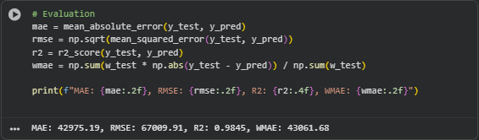

9.2 Power BI Dataset Creation Summary
After completing the forecasting process for all Walmart stores, the combined dataset was successfully generated and exported as File Name Walmart_Sales_Forecast_AllStores.csv
Img 9.2.1
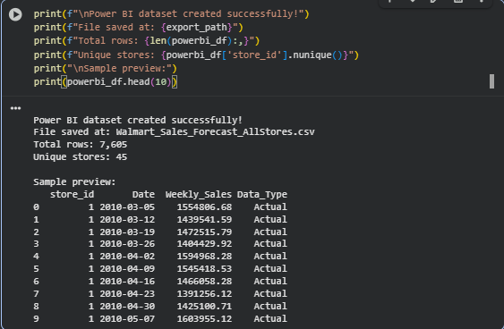

9.2.1 Sample Data Preview Table
store_id | Date | Weekly_Sales | Data_Type
1 | 2010-03-05 | 155,486.68 | Actual
1 | 2010-03-12 | 143,951.54 | Actual
1 | 2010-03-19 | 147,215.79 | Actual
- Each store_id represents a unique Walmart store (1–45).
- The Date column captures the weekly sales timeline.
- The Weekly_Sales column records actual or forecasted sales values.
- The Data_Type column distinguishes between:
  - Actual – historical observed sales
  - Forecast – model-predicted future 30 weeks of sales

Purpose of This Dataset
This consolidated file serves as the final dataset for Power BI visualization.
It allows the user to:
- Filter by store, date range, or data type (Actual/Forecast)
- Compare historical vs predicted sales trends
- Creating visual insights for each of the 45 Walmart stores

Actual vs Predicted Weekly Sales – Store 1 (For Example)
The chart above visualizes the performance of the XGBoost regression model in predicting weekly sales for Store 1.

Plot
- The blue solid line represents the actual weekly sales observed historically.
- The orange dashed line represents the model’s predicted weekly sales for the same period.
- The X-axis indicates the weekly dates, while the Y-axis represents the weekly sales values in dollars.

Observations
- The predicted sales curve closely follows the trend of the actual sales, showing the model captures the seasonal and weekly sales patterns effectively.
- Some minor deviations occur at sales peaks and troughs, which are common due to:
  - Sudden changes in customer demand (e.g., holidays, promotions, weather).
  - External factors not explicitly modeled (e.g., regional events or store closures).
- The trend alignment and phase match between actual and predicted lines confirm that the model generalizes well and learns from historical fluctuations.

Insights
- The model shows high predictive accuracy for Store 1, as seen by the close overlap between the two lines.
- This consistency aligns with the overall R² score of 0.9845, confirming that 98.45% of sales variation is explained by the model.
- This type of plot was generated for all 45 stores to validate that the model performs reliably across the entire network.
Img 9.3.1 Testing Plot
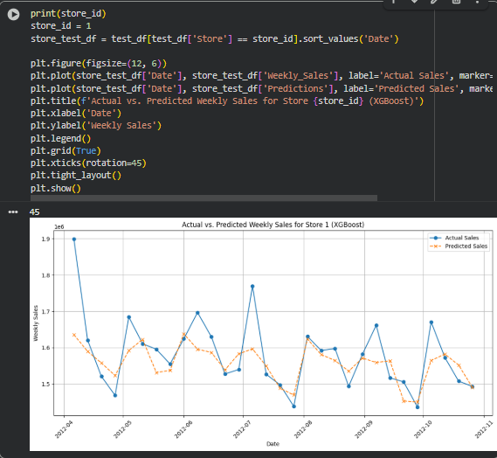

PowerBI Dashboard

The final output would be the dashboard of the Walmart stores. In that dashboard we can select the stores by Store_id, Actual / Forecast mainly average, minimum, maximum sales than total sales too.

Img. 9.3.2 Dashboard

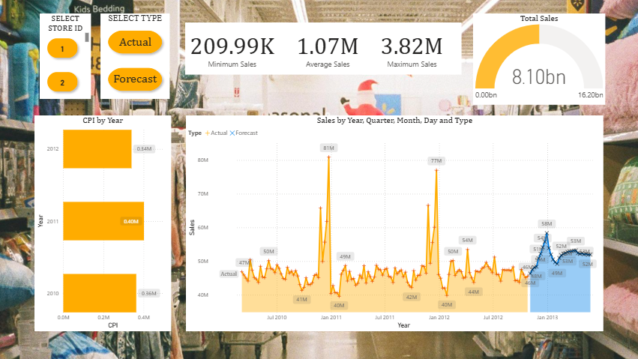

CONCLUSION
The Walmart Weekly Sales Forecasting System successfully demonstrates how data analytics and machine learning can be applied to predict future sales trends using historical data. Through the integration of Python for data preprocessing, model building, and forecasting, along with Power BI for visualization, the project provides an efficient, accurate, and visually appealing solution for sales prediction.
The system analyzes past sales patterns, identifies seasonal trends, and forecasts future sales, helping Walmart management make data-driven decisions such as inventory planning, workforce management, and promotional scheduling.
This project not only enhances understanding of time series forecasting techniques but also shows the importance of data visualization in simplifying complex results for better interpretation.
Overall, the Walmart Sales Forecasting Project achieves its main goal of developing a user-friendly, accurate, and insightful forecasting model that can be easily adapted to other retail environments as well.

11.REFERENCE

- Google Colab Note Book (Project Implementation)
- Python Learning(About Python)
- Project Ouput Dashboard (PowerBI)
- PowerBI Tutorial

